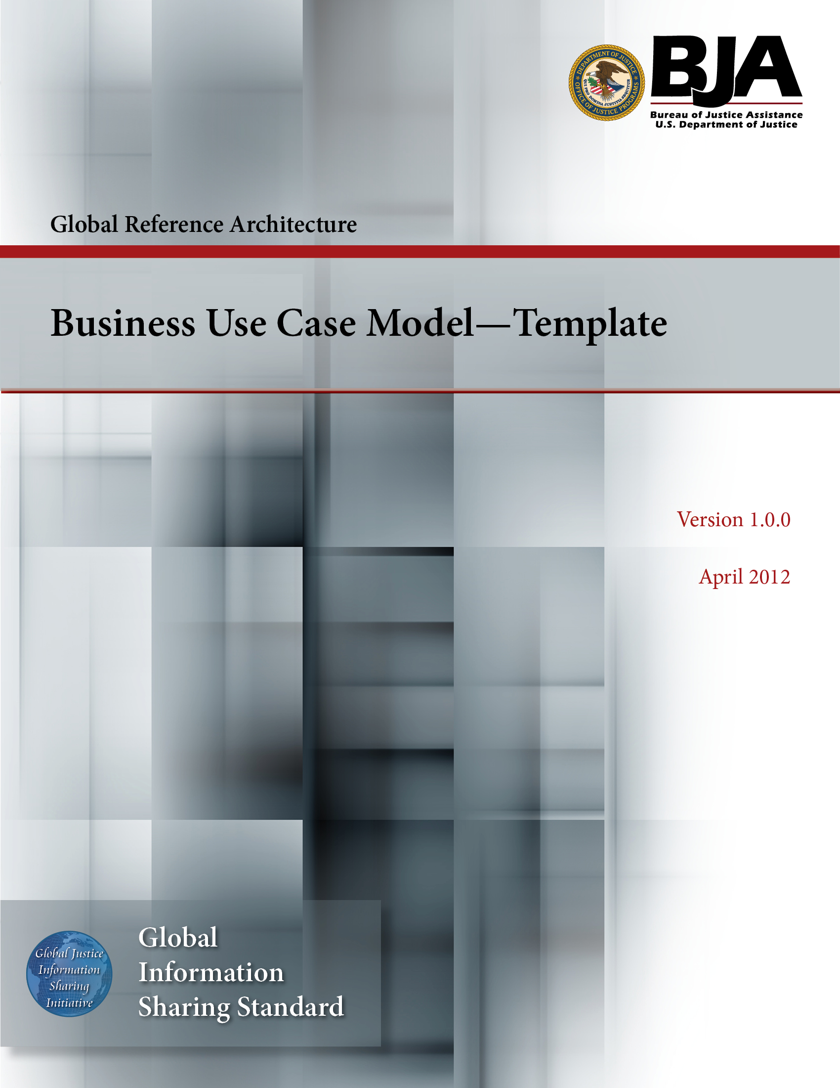


The Global Reference Architecture (GRA)

[Service Name] [Service Abbreviation] [Service Version]

Business Use Case Model (Template)

Version 1.0.0

By [Name of Organization]

[Month Year]

Table of Contents

Document Conventions ii
1. Introduction 1
1.1 Purpose 1
1.2 Scope 1
1.3 Definitions, Acronyms, and Abbreviations 1
1.4 References 1
1.5 Overview 1
2. Overall Description 2
2.1 Business Use Case Model 2
2.2 Actor Descriptions 2
2.3 Use Case Specifications 2
3. Additional Requirements 2
Appendix A—References 3
Appendix B—Glossary 4
Appendix C—Document History 5

Document Conventions

[Note: The following template is provided for use with the Service Development Process. Text enclosed in square brackets and/or displayed in blue is included to provide guidance to the author and should be deleted before publishing the document.]

<Project Name> Business Use Case Model

Introduction

[The introduction of the Business Use Case Model provides an overview of the entire document. It includes the purpose, scope, definitions, acronyms, abbreviations, references, and overview of the Business Use Case Model Document.]

Purpose

[Specify the purpose of this Business Use Case Model. The Business Use Case Model fully describes the behavior of the application identified in business terms. It also includes nonfunctional business requirements and other factors necessary to provide a complete and comprehensive description of the requirements in terms of the business.]

Scope

[A brief description of the business case that the Business Use Case Model applies to and anything else along with that is affected or influenced by this document.]

Definitions, Acronyms, and Abbreviations

[This subsection provides the definitions of all terms, acronyms, and abbreviations required to properly interpret the Business Use Case Model. This information may be provided by reference to the project’s Glossary.]

References

[This subsection provides a complete list of all documents referenced elsewhere in the Business Use Case Model. Identify each document by title, report number (if applicable), date, and publishing organization. Specify the sources from which the references can be obtained. This information may be provided by reference to an appendix or to another document.]

Overview

[This subsection describes what the rest of the Business Use Case Model contains and explains how the document is organized.]

Overall Description

Business Use Case Model

[This section contains the use-case model including diagrams. An overview and description of the business is a good enclosure to this section.]

Actor Descriptions

[This section includes a list of all actors and corresponding brief descriptions.]

Use Case Specifications

[This section includes all use cases and corresponding use case specifications. These specifications could be handled as separate documents and be included as a reference or could be stored within the context of this document.]

Additional Requirements

[This section of the Business Use Case Model contains any additional business requirements that are not captured above.]

Appendix A—References

[This section is used to list applicable references.]

[Reference name and description] | [Fully qualified link/path to the reference information]

Appendix B—Glossary

[This section is used to list glossary terms used in the document.]

[Glossary term or acronym] | [Glossary term or acronym description]

Appendix C—Document History

[This section is used to document the history of the service description document.]

Date | Version | Editor | Change
December 11, 2011 | 1.0.0 | James Dyche  Iveta Topalova | Final 1.0.0 revision
December 20, 2011 | 1.0.0 | David Gillespie | Initial edit of 1.0.0 revision
April 2012 | 1.0.0 | Global Standards Council (GSC) | Global Advisory Committee (GAC) approved



